**Leader Overview**

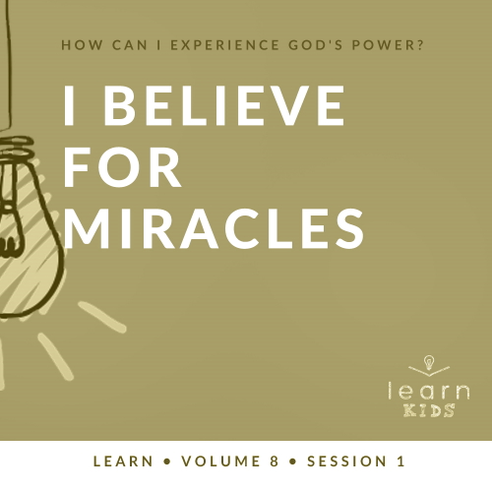

**Volume Overview**

**How can I experience God’s power?**

*When we think of power, we might think of physical strength or mental toughness. While God surely wants us to experience physical health and clarity of mind, He desires that we experience His supernatural power too.*

*In the Bible, it’s clear that our God—revealed through the Father, the Son and the Holy Spirit—is powerful. He spoke the world into existence and sustains the universe by the power of His Word (*[*Hebrews 1:3*](https://ref.ly/logosref/Bible.Heb1.3)*). God displayed His power in many ways in the Old Testament for His people. In the New Testament, Jesus’ life and works revealed His power over sickness, spiritual forces, and even the grave. After Jesus’ resurrection, God sent the Holy Spirit so we could have the power to do kingdom work today (*[*Acts 1:8*](https://ref.ly/logosref/Bible.Ac1.8)*). Clearly, God is powerful! But how do you and I experience His power? That’s the question we’ll explore in this volume.*

**Session Overview**

**I Believe for Miracles**

*We see God’s miracles throughout the Old and New Testaments, and He still performs miracles today. God sees our needs and provides for us just like He provided for Elijah when he needed food and water.*

**Bible Lesson**

Elijah and the Ravens

[1 Kings 17:1–6](https://ref.ly/logosref/Bible.1Ki17.1-6)

**Faith Fact**

I believe God can do miracles.

**Faith Verse**

[John 14:12](https://ref.ly/logosref/Bible.Jn14.12) (NLT)

“I tell you the truth, anyone who believes in me will do the same works I have done.”

**Preparing for the Session**

**Leader Preparation Time: 20–25 Minutes**

|  |
| --- |
| ***You Will Need***  ***Large Group***   * *Bible* * *Worship songs (Song suggestions: “Way Maker” by Hillsong Worship; “Miracles” by Vertical Worship; “Nothing Is Impossible” by Planetshakers; “Love Won’t Let Me Down” by Hillsong Young & Free)* * *For groups not using a phone or tablet only, add:*   *• Projector or TV*  *• Laptop*  *•* ***Faith Fact Slide***  *•* ***Faith Verse Video*** *or* ***Slide***  *•* ***Bible Lesson Video***  *•* ***Teaching Point Slides******1–3***   * *Glass bottle* * *Balloon* * *Baking soda* * *Vinegar* * *Funnel* * *Toy car with tires* * *Can of soup* * *Table* * *Sheet or tablecloth* * ***Large Group Prayer Response Page****, one per ten kids* * *Pencils or pens, one per kid* * *Scissors*   ***Small Group***   * *Bibles for kids in your group to share* * *Floor-safe tape* * ***Small Group Activity Page****, one per kid* * *Pencils or pens* * *Markers or crayons* * *Bibles, one per kid if possible*   *To access session content and videos from a computer, visit:* [*BibleEngagementProject.com/downloads*](https://bibleengagementproject.com/downloads) |
| ***Getting Ready***  ***Large Group***   * *Download videos and slides if needed.* * *Select worship song(s) and have them ready to play.* * *Read the Bible Lesson Scripture to prepare for Teaching Time.* * *Set up the table where you will be doing the science experiment.* * *Place all of the science experiment supplies (glass bottle, balloon filled with baking soda, vinegar, and funnel) on the table and cover them with a sheet or tablecloth.* * *Print copies of the* ***Large Group Prayer Response Page****, one per ten kids.* * *Cut apart the slips.*   ***Small Group***   * *Place a strip of floor-safe tape on the floor at least ten feet away from where you will stand as you lead.* * *Print copies of the* ***Small Group Activity Page****, one per kid.*   *First time leading* Learn *for Kids? Check out the* [*Facilitator Guide*](https://0b769b0ed3569ef9d18b-f88d8272f61086866d50d048b43ef630.ssl.cf2.rackcdn.com/sites/biblengagementproject/Listen_Facilitator_Guide.pdf)*.* |

**Large Group**

**30 Minutes**

*See what’s needed at the beginning of the session.*

**Introduction**

Welcome, everyone! We’re beginning a new volume that asks: How can I experience God’s power? That’s a great question! Who would love to experience God power in your life? *(Group response)* Me too! We can always ask for more of God’s power. His power never runs out, so we can never use up all that God has for us. There will always be more!

Today, we’ll learn how God’s power is revealed through miracles. A miracle is something only God can do. Did you know God has the power to do miracles? *(Group response)* Do you know God still does miracles today? *(Group response)* He’s still working and moving in powerful ways, and we can trust in His power.

**Faith Fact**

That leads us to today’s Faith Fact. Our Faith Fact is **I believe God can do miracles.**

• *Show the* ***Faith Fact Slide.***

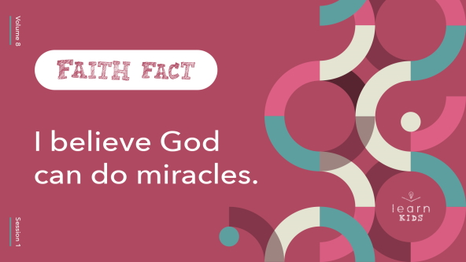

Let’s say that together a few times. We’ll start by saying it very quietly in a whisper and then grow louder each time we say it. **I believe God can do miracles.**

• *Lead the kids in saying the Faith Fact a few times, growing louder each time.*

Amazing job! Our Faith Fact is definitely worth shouting loud enough for everyone to hear.

**Game**

**Believe It or Not?**

We’re going to play a game called “Believe It or Not?” Sometimes people struggle to believe God can do miracles. Other people might even tell you miracles don’t happen anymore. That same thing happens with other facts too. Many true things are hard to believe. And there are also things we’re told that can’t be backed up by truth.

I’ll read a statement. Then you’ll choose if you believe it’s true or not. Give a thumbs-up if you believe the statement is true. Give a thumbs-down if you believe the statement is false.

• *Read these statements and let the kids respond.*

• *Reveal the answer after everyone has made their choice.*

1. Eating carrots can keep your eyes healthy. *(Group response)* True

2. Sugar makes you super hyper. *(Group response)* False

3. Chewing gum is illegal in the country of Singapore. *(Group response)* True

4. A jelly bean takes about a week to make. *(Group response)* True

5. Drinking coffee can make you shorter. *(Group response)* False

6. A dog was the mayor of a town for four years. *(Group response)* True

7. Some dinosaurs had feathers. *(Group response)* True

8. Crocodiles are more closely related to lizards than to birds. *(Group response)* False

9. The city of Boston was nearly destroyed by a flood of molasses, which is a lot like pancake syrup. *(Group response)* True

10. You shouldn’t swim right after you eat. *(Group response)* False

How did you do? Did your beliefs match the truth? *(Group response)* Did you learn something new today? *(Group response)* That’s awesome! Some of the things I asked you about were things we eat. That’s a hint about the miracle we’re going to talk about later. Get ready to hear about something even more unbelievable—but true—that God did for the prophet Elijah in our Bible story today.

**Worship**

But first, it’s time to worship our miracle-working God. If you believe our God is powerful, I want you to worship Him by singing today with all you have!

• *Lead the kids in singing one or two praise songs. See suggestions at the beginning of the session.*

**Bible Lesson**

Thanks for singing to and worshipping God with me today. He loves it when we take time to worship Him. Now we’ll hear what God has to say to us through His Word. When you read in the Bible, you’ll see over and over how God’s power is revealed to people. God did so many miracles. We’re going to look at just one of those miracles today.

This miracle might feel a little small or not that important, but there is no such thing as a small miracle. Nothing is too big or too small for God! He cares about His people, and He provides everything they need. As we prepare to dig into God’s Word, let’s pray and ask Him to teach us something new today.

**Prayer**

|  |
| --- |
| *Dear God, we’re so thankful that You are all powerful and can meet every need we have. Help us block out any distractions as we learn from Your Word today. Amen.* |

**Video Intro**

Just before we look at the Bible story, let’s watch this video.

• *Play* ***Bible Lesson Video****.*

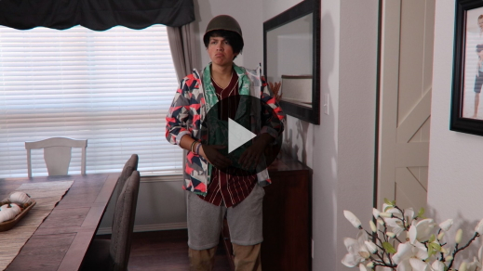

**Bible Story**

**Elijah and the Ravens**

What a fun lead-in to our Bible story today—a washing machine miracle! I have a question for you. Have you ever been so hungry you thought you might pass out? *(Group response)* Maybe that’s a bit of an exaggeration, but everybody knows what it’s like to feel hungry, even the prophet Elijah.

In our Bible story today, Elijah told the king it wasn’t going to rain for three years. That meant there wouldn’t be much food because crops need water to grow. But God took care of Elijah and met his physical needs. I love how God does things differently and is always surprising us! He didn’t just feed Elijah. God did it in a super creative way.

Now that I have your attention, grab your Bible or open the Bible app on your device and go to [1 Kings 17:1–6](https://ref.ly/logosref/Bible.1Ki17.1-6) to read along. Let’s find out how God delivered the food and water Elijah needed.

• *Read the Bible story aloud to the group.*

• *In order to keep Large Group time moving along, we don’t recommend having the kids read.*

• *Optional: Remind the kids to mark this place with their Bible Bookmark, so they can read it on their own at home.*

**Teaching Time**

|  |
| --- |
| ***You Will Need***   * *Glass bottle* * *Balloon* * *Baking soda* * *Vinegar* * *Funnel* * *Toy car with tires* * *Can of soup* * *Table* * *Sheet or tablecloth*   ***Getting Ready***   * *Set up the table where you will be doing the science experiment.* * *Place all of the science experiment supplies (glass bottle, balloon filled with baking soda, vinegar, and funnel) on the table and cover them with a sheet or tablecloth.* |

What miracle did God do for Elijah in our Bible story? *(Allow responses.)* We know God did miracles back in Bible times. But do you believe God can still do miracles today? *(Group response)* Thanks for your honesty! If anyone has doubts, I hope we’ll be able to clear them up as we learn what the Bible says about God’s power.

We’re not powerful enough to do miracles on our own, but we can do our part. Our part is to believe what God says. Say, “Believe,” with me. *(Group response)* And to obey what God says. Okay, now say, “Obey!” *(Group response)* When we really believe God, we obey everything He says—even the things we don’t understand. That gets us ready for His miracles!

Remember our Faith Fact? **I believe God can do miracles**. Say that with me in your most powerful voice. **I believe God can do miracles**.

Let’s talk about three things we can know and believe about miracles.

**1. Miracles come from God.**

• *Show the* ***Teaching Point 1 Slide.***

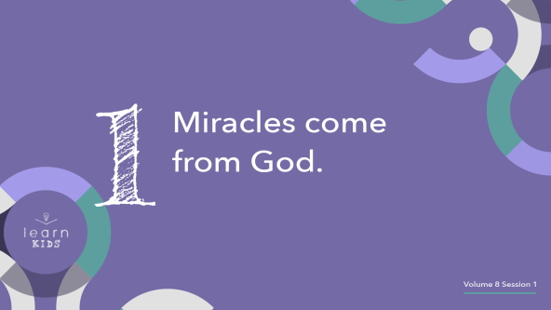

Miracles are events that are mostly unexplainable! That means they can’t be figured out or explained by science or human logic. Science can accomplish and do many incredible things. Some science experiments might even seem like miracles, but they are always explainable. Take this experiment, for example.

• *Uncover the glass bottle, balloon filled with baking soda, vinegar, and funnel on the table.*

First, I’ll put vinegar inside this glass bottle. Then, I’m going to attach a balloon filled with baking soda to the top of the bottle. What do you think will happen next? *(Allow responses.)* Let’s find out!

• *Pour some vinegar in the glass bottle.*

• *Tightly attach the opening of the balloon to the mouth of the bottle. Then allow the baking soda to fall from the balloon into the bottle. The balloon should begin to inflate, but it won’t pop.*

That’s pretty amazing, but it can be explained by science. The vinegar and baking soda reacted to each other, creating a gas that expanded or inflated the balloon. Even then God had a part in it. The chemical reaction was created by God in the first place. That’s true about miracles too. But unlike science experiments, miracles can’t be explained. Miracles are supernatural because they come from God!

**2. We must depend on God for miracles.**

• *Show the* ***Teaching Point 2 Slide.***

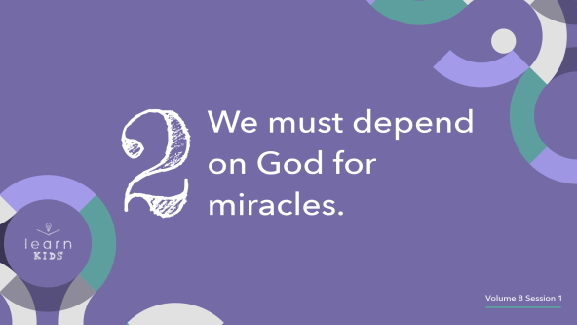

Miracles often happen when we see how much we need God’s power to work in our life. It’s important that we know we need God’s help and ask for it. We can’t make miracles happen—only He can! Many times we try to do things in our own strength first. Does that usually work? *(Group response)* We can do some things on our own, but why would we even want to try when we’re facing difficult things? I’ll show you what I mean.

• *Hold up the toy car and point to the tires.*

Here’s a great example of the difference between depending on God’s power and trying to use our own power. When we try to do things on our own, we’re like these tiny tires on a toy car. Do they work? *(Group response)* Yes, they do. They roll back and forth like tires should. But would they work on the big car you came here in today? *(Group response)*

These tires are small and not very powerful, so they won’t get you very far. If you put too much weight on them, they would just break and your car would be stuck. Depending on God’s power is like putting full-size tires on your car. We can go way farther and handle a lot more with God’s help. Nothing is too big or powerful for God to handle. When we ask God for help, He always answers us. He may not do a miracle right away or answer the way we want Him to, but He always has a reason and a plan. We can trust God to decide when it’s best to do miracles in our life.

**3. God can do miracles in our life.**

• *Show the* ***Teaching Point 3 Slide.***

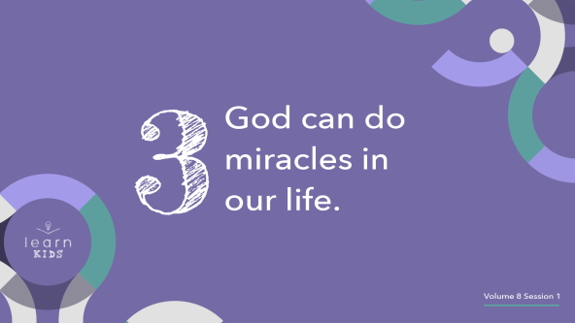

God has the power to work miracles in our life and through our life! This means when we need a miracle, God is the right One to turn to. It might be easier for you to believe God will do a miracle for someone else. Maybe you need God to heal your sore throat, but someone you know needs healing from cancer. It’s easy to believe God would be more likely to care about and heal the person with cancer than to heal your sore throat. But no matter how small or big you believe your needs are, God still cares about you. The Bible is full of miracles that are both big and small.

• *Hold up the can of soup.*

Did you know that one time in the Bible God took the poison out of some soup so a group of prophets could eat it safely? *(Group response)* God healed soup! If God cared about whether or not people in the Bible had lunch, you can know for sure that He cares about every little detail of your life too. Don’t be afraid to believe God can do a miracle for you no matter how small or how big it is.

**Prayer and Response**

*Consider playing a worship song softly in the background while kids pray.*

|  |
| --- |
| ***You Will Need***   * ***Large Group Prayer Response Page****, one per ten kids* * *Pencils or pens, one per kid* * *Scissors*   ***Getting Ready***   * *Print copies of the* ***Large Group Prayer Response Page****, one per ten kids.* * *Cut apart the slips.* |

Does anyone remember what I said we need to do when it comes to miracles? *(Allow responses.)* That’s it. We have to believe! Let’s practice believing God for miracles in our life right now. You’ll get a slip that says, “I believe God will …” and a pencil. Take a few moments to pray and write down a miracle you believe God can do in your life. It might be healing for someone who is sick, help for a family situation, or money for something you need. Write at least one thing down. Then ask God to do a miracle and believe He can.

Remember, God may do a miracle right away or He may not. Keep believing and asking Him. God always knows what’s best and may not answer the way you want Him to. We have to trust that His way is the best, and He has a plan no matter what happens.

• *Hand out pencils and* ***Large Group Prayer Response*** *slips to the kids. Help younger kids write or draw something on their response slips.*

**Prayer**

• *Optional: Have the kids repeat phrases of the prayer after you.*

|  |
| --- |
| Dear God, I believe You are a powerful God who still does miracles. Help me believe You can even when I don’t see it with my own eyes. Amen. |

**Faith Verse**

It’s time to start to learn a brand-new Faith Verse today! Are you ready? *(Group response)* Our Faith Verse is found in [John 14:12](https://ref.ly/logosref/Bible.Jn14.12). Jesus said, “I tell you the truth, anyone who believes in me will do the same works I have done.” Let’s learn the verse and do the actions together.

• *Play* ***Faith Verse Video****.*

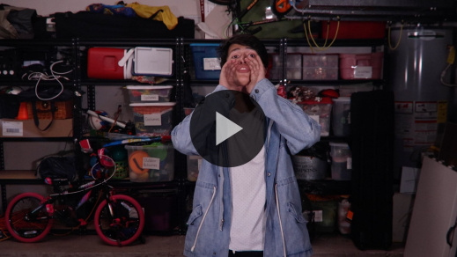

[John 14:12](https://ref.ly/logosref/Bible.Jn14.12) (NLT)

“I tell you the truth, anyone who believes in me will do the same works I have done.”

That’s a powerful verse! It means if we believe in Jesus, He can give us power to be used by Him to do amazing things.

**Faith Fact**

Before we go to our small groups, let’s review our Faith Fact again.

• *Show the* ***Faith Fact Slide****.*



Say it with me in your strongest voice: **I believe God can do miracles.** Are you ready to learn more about God and His amazing power to do miracles in your life? *(Group response)* I’m so glad you want to know more about God’s power! We’ll learn even more over the next few times together, so don’t miss it!

• *Dismiss kids to Small Group time or to go home if your group time ends here.*

**Small Group**

**30 Minutes**

*This section can be done in conjunction with the large group or on its own if you do small groups with your kids. During Small Group time, the goal is to connect the kids with the Word of God and to each other. All activities are led by the small group leader.*

**Group Connection**

**Spot the Truth**

Sometimes it’s hard to have faith and believe in God when the world wants us to believe something different. If we listen to people more than we read and trust God’s Word, we can get confused. Let me show you what I mean.

We’re going to see how well you know each other. Can you spot the truth? Each person will share one thing about themselves that is true and one thing that is not. Everyone else will vote on which statement was true.

• *Start by sharing your true and false statements.*

• *Go around the group, letting kids each share one true thing and one untrue thing about themselves.*

• *Allow others in the group to vote on which statement is the truth before allowing the kid to reveal the truth.*

• *Make sure everyone has a chance to share at least one time.*

Were you good at spotting the truth? *(Group response)* The best way to know if something is the truth in your life is to find out if it lines up with God’s Word. If it goes against what the Bible says, it’s not the truth.

**Learn about It**

|  |
| --- |
| ***You Will Need***   * *Bibles for kids in your group to share*   *No prep is needed.* |

**Scripture Search:** [**Mark 9:23–24**](https://ref.ly/logosref/Bible.Mk9.23-24)**;** [**Mark 16:17–20**](https://ref.ly/logosref/Bible.Mk16.17-20)**;** [**Acts 3:12–13**](https://ref.ly/logosref/Bible.Ac3.12-13)**;** [**Philippians 4:19**](https://ref.ly/logosref/Bible.Php4.19)

I love looking at what different parts of the Bible have to say about the same subject. Let’s dig deeper into God’s Word and hear what God says about believing in His power. As we find and read each of these verses, let’s think about this question: What does this Scripture mean for our life today?

• *Give each kid a Bible and search for one or more of the Scriptures as a group (as time allows). When everyone has found the Scripture, have one of the kids read it. Then answer the question about it: What does this Scripture mean for our life today?*

• *Pair kids who need additional help with older kids or start simple and look up the session’s Bible story Scripture:* [*1 Kings 17:1–6*](https://ref.ly/logosref/Bible.1Ki17.1-6)*. Kids will get better at finding Scriptures the more they practice.*

• *Optional: Make this a competition to see who can find the Scripture first.*

**Bible Reading Tip**

Did you know you can experience God’s power by reading or hearing His Word? *(Group response)* It’s true! God’s Word is living and active. The Book of Hebrews says it’s like a two-edged sword. That sounds really powerful to me. But how can we experience God’s power if we don’t take the time to read His Word? When you read your Bible, look for the ways God shows His power. Write them down or highlight them in your Bible as you read along. You’ll soon begin to notice God’s power in the entire Bible.

**Challenge**

As you read your Bible this week, look for verses that show how powerful God is. Write down one verse or example that you believe shows His power. Bring it next time to share with your small group.

**Faith Fact**

Who remembers today’s Faith Fact? *(Allow responses.)* Great job! **I believe God can do miracles.** Let’s do the opposite of what we did at the beginning of our Large Group time. Let’s start out saying the Faith Fact as loud as possible and then get quieter each time we say it. Do you think you can do it? *(Group response)* Let’s go!

• *Lead the kids in saying the Faith Fact a few times, starting loud and getting quieter each time.*

**Group Discussion**

*Feel free to use all or just a few questions as a jumping-off place for good discussion. Questions marked with * are designed for more conversation. Adjust the questions based on the age or maturity of your group. Typically, older kids will be able to dive a little deeper than younger ones.*

**Questions**

• *If small group activities are not immediately following large group time, you may want to read the Bible story passage before this discussion.*

At the beginning of our Bible story, what did Elijah tell the king would not happen for the next few years?

How did Elijah get food?

* What is something you believe that other people might not believe?

* What is something that is hard for you to believe? Why?

Do you try to do things on your own first and then ask God for help, or do you ask God for help first?

* Have you ever seen a miracle? What happened?

Is it easier to believe in miracles after you have already seen God do something amazing for someone else? Why or why not?

Why do you think God doesn’t always perform miracles when we ask Him to?

How can you continue to trust God even if He doesn’t do the miracle you asked for?

**Prayer Requests**

*Finish group discussion by sharing prayer requests and praise reports. Keep track of your small group’s prayer requests and review them each time you meet.*

**Prayer**

*Have kids pray for each other’s prayer requests.*

**Faith Verse Review**

|  |
| --- |
| ***You Will Need***   * *Floor-safe tape*   ***Getting Ready***   * *Place a strip of floor-safe tape on the floor at least ten feet away from where you will stand as you lead.* |

We’re learning a brand-new Faith Verse together today from [John 14:12](https://ref.ly/logosref/Bible.Jn14.12). I love that it’s a powerful promise from Jesus to us. It teaches us how important it is to believe in God. Let’s learn it together.

• *Show* ***Faith Verse Video****.*



[John 14:12](https://ref.ly/logosref/Bible.Jn14.12) (NLT)

“I tell you the truth, anyone who believes in me will do the same works I have done.”

What an awesome promise from Jesus! Let’s review the verse together a few more times. Try to memorize it so you’re ready for our fun game.

• *Lead the kids in saying the Faith Verse another time.*

**Faith Verse Fun**

**Beeline Verse**

Okay, I think you’re ready for the verse game. You’ll need to know the verse and be superfast! Are you ready? *(Group response)*

Line up in two teams facing me. When I say, “Go,” the first person on each team will race to me. Whoever gets here first will say as much of the Faith Verse as they can. Then the rest of us will help them finish the verse. The first person who wins the race for their team and can say the entire verse on their own will be the winner. Let’s play!

• *Play until at least one kid in your group can say the entire verse on their own.*

You were so fast! We’ll keep practicing our Faith Verse next time, so all of us can get it down!

**Activity Page**

**Match the Miracle**

|  |
| --- |
| ***You Will Need***   * ***Small Group Activity Page****, one per kid* * *Pencils or pens* * *Markers or crayons* * *Bibles, one per kid if possible*   ***Getting Ready***   * *Print copies of the* ***Small Group Activity Page****, one per kid.* |

There are a lot of miracles in the Bible! For this activity, you’ll look up the verses and match each miracle with one of the pictures. Keep going until you’ve found all the matches.

• *Give each kid an* ***Small Group Activity Page****, pencil, Bible, and crayons and let them complete the activity.*

How cool to see the variety of miracles God did in the Bible! Which of these miracles is your favorite? *(Allow responses.)* God does unique and special things for different people and situations. He is a personal God. That means He answers each of us and takes care of our needs in a special way.

**Dismissal**

Here’s what I want you to remember as we close today. God is all-powerful! There is nothing He can’t do. He has power over everything and everyone. Our part is to believe in Him and His power. Let’s close in prayer.

**Prayer**

|  |
| --- |
| *Dear God, thank You for all the miracles You have already done. Thank You for all the things You are still doing today. Help us believe in You and Your power, and not doubt. Amen.* |

**Faith Fact Recap**

• *Show the* ***Faith Fact Slide****.*



Let’s say the Faith Fact one more time. **I believe God can do miracles.** I’m so glad you came today. Don’t forget to come back next time to hear more about how we can experience God’s power! See you then!

• *Send home the* ***Small Group Activity Page*** *and the* ***Large Group Prayer Response*** *slip****.***

• *Remind parents that there are* ***Family Devotions*** *available on the app to do with their kid.*

• *Tell everyone the date and time for the next session.*